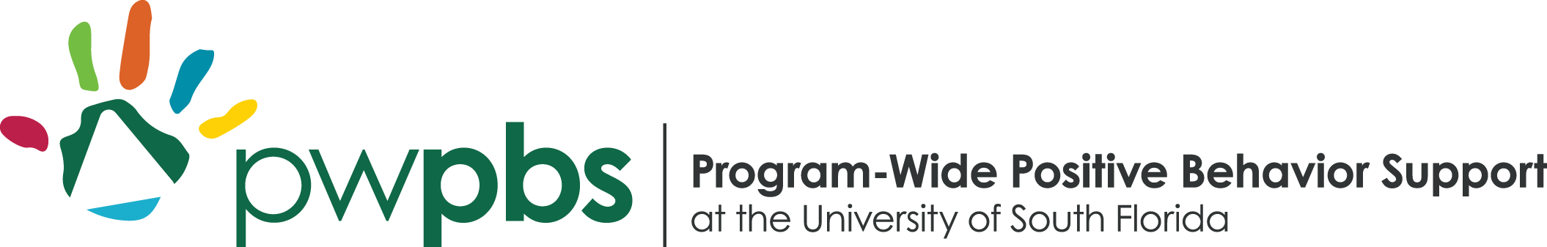

Winter and Spring 2025 Training Series

A NO-COST workshop series funded by the Children's Board of Hillsborough. Sessions focus on effective strategies that promote social-emotional development and address challenging behavior in young children from birth to five years old through the implementation of the Pyramid Model.

Training will be held at
Children’s Board of Hillsborough County
1002 E Palm Ave, Tampa, FL 33605

Heart-to-Heart: Fostering Friendship Skills in the Early Years
Saturday, February 1, 2025 (8:30 am-11:30 am)
This workshop will explore the importance of friendship and provide practical strategies to foster strong social connections in your early childhood environment. Learn how to teach and reinforce essential friendship skills like taking turns, inclusive play, and inviting others to join in the fun. You'll receive valuable tips, engaging activities, and adorable make-and-take materials to implement friendship skills with all ages of young children.

Give Me 5! Tips for Improving Behavior in the Classroom
Saturday, March 29, 2025 (8:30 am-11:30 am)
This interactive workshop will provide step-by-step guidance for implementing proven behavior strategies. Learn practical tips for preventing and addressing challenging behavior and leave with ready-to-use resources and a renewed sense of confidence!

Building Stronger Foundations: Effective Family Communication and Partnerships
Saturday, May 17, 2025 (8:30 am-11:30 am)
Come explore the tools needed to construct strong and lasting partnerships with families. Through hands-on activities and practical resources, you will learn to build bridges of understanding by communicating effectively with families and helping families to implement social and emotional strategies at home.

Let’s Be Problem Solvers
Saturday, June 7, 2025 (8:30 am-11:30 am)
Explore practical strategies to help our youngest learners be problem solvers! A variety of strategies will be shared that enable young children to learn the steps of problem-solving and identify and use solutions to help solve social problems in the classroom environment. These practical teaching strategies will include taking a closer look at creating and using scripted stories to teach a new skill.

Register here: https://usf.az1.qualtrics.com/jfe/form/SV_3ko5v3gCiDCjNdA
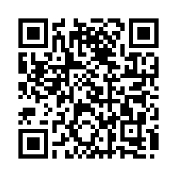

USF is an Equal Opportunity/Equal Access Institution. For reasonable accommodations for a disability, contact Mary Cifuentes at 813-974-4346 or via email, mcifuentes@usf.edu, a minimum of five (5) working days in advance, preferably ten.

